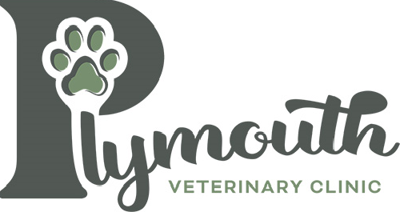
1201 E Jefferson Street
Plymouth, IN 46563
574-936-2232
Plymouthvet2232@embarqmail.com
PlymouthvetclinicIN.com

Adoption Policy
At Plymouth Veterinary Clinic, our mission is to build better lives for pets and the people who love them. On occasion, we here at Plymouth Veterinary Clinic will take in a patient who was found as an injured stray or a surrender. Our goal is to provide necessary medical care for these patients and place them in a home where they will continue to receive necessary treatment, preventative care tailored to their personal needs.
- All applicants must be 18 years or older
- Applicants must agree to have the pet spayed/neutered, provide final vaccines & veterinary care
(if needed)
- Any applicant renting must have a written permission from landlord
- All adults in the home must be aware of the responsibilites of pet ownership before adopting
- All applicants must adhere to all laws & ordinances
- We do not permit the adoption of animals as gifts for someone else
- We do not adopt out dogs for the sole purpose of security
We encourage meet and greet and/or a trial period to make sure you and the animal are a good fit for each other.
If, for any reason, the animal does not work out in its new environment, we ask that you contact the clinic for help in rehoming it.
We highly encourage considering any small children in the home and understanding the responsbility to ensure property training, education and safety for the pet and children.

